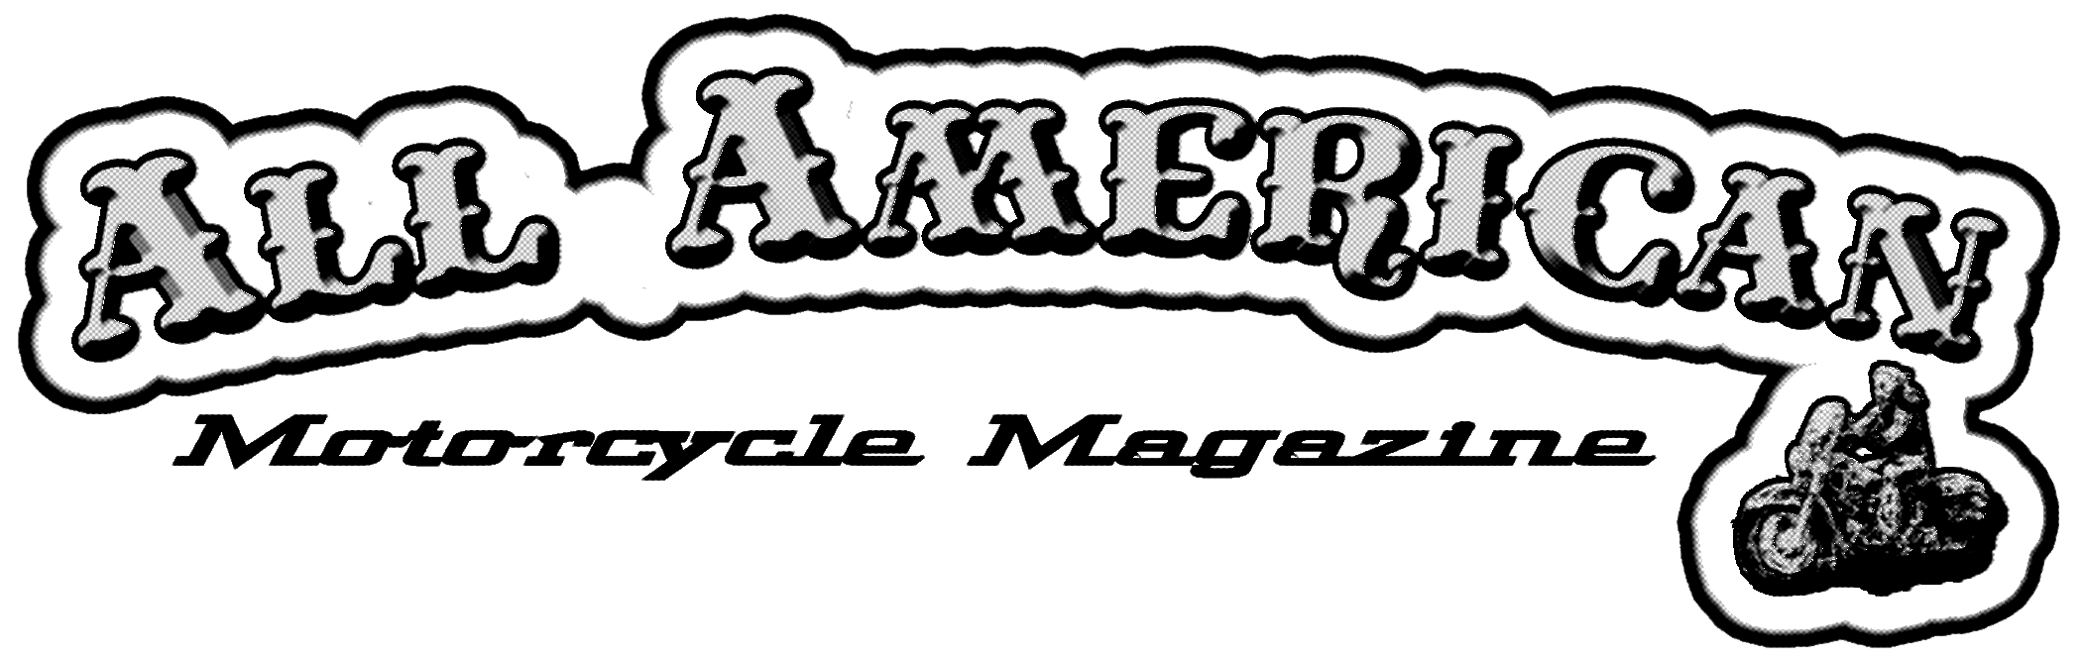
Dedicated to American Motorcycles & the Folks Who Ride Them

May 1, 2006

Thank you for reviewing our Press/Media Kit for advertising in The All American Motorcycle Magazine. Our publication has gone from a Northwest Regional Motorcycle subscription of 2500 to a Nationwide publication of 12,000 in 35 states in the last year. Our current subscriptions are at 6000 Biker residences nationwide and we now have over 190 distributors in 35 states, mostly custom motorcycle shops and HD & other dealerships. We also provide magazines at motorcycle runs and function all over the country. Our July distribution will be 20,000 issues.
We receive subscription and distributer requests on a daily basis. Since we added subscription requests to our web site we now get a total of 35 to 60 new subs each week.
We are a Free Motorcycle publication that has evolved over 20 years, from a newsprint tabloid to a full color slick Magazine. The difference between ours and most free mags is that over 1/2 of our magazines are in the homes of our readers within a week of printing and not sitting on a motorcycle shop shelf all month long. We send small bundles to our distributors to prevent your ads from being thrown away at the end of the month. The All American Motorcycle Magazine is an “old School” type of publication with lots of motorcycles, events and tech info and feature articles of interest to American Motorcycle Riders. We feature biker art and fiction as well as product and tech news. Our motto is proudly stated on our Masthead. “Dedicated to American Motorcycles and the Folks Who Ride Them.” Our last couple of issues are included for your review.
Please look over our statistics and distribution methods and especially our Rate Sheet which is the most cost effective and results oriented of any other Free Motorcycle publication available. Our advertising rates have not been raised since distribution was at 4500. In July when we reach 20,000 issues we will have about a 10-12% rate hike to reflect our increased production costs and circulation increase. All contracts written up, before the rate change goes in, will be guaranteed the current rate. This is an excellent time secure a great deal on this years advertising, with the fastest growing motorcycle magazine on the planet.
Our art production is full service computer capable graphics and design which we provide for no additional charge or we gladly accept camera ready copy or most digital formats. Please contact me with any questions, requests or concerns.

Sincerely,
Rusty Savage

RL Savage • 329 Main St • Springfield, OR 97477 • 541 868-0899 • www.allamericanmotorcycle.com
2007 Rate Sheet Effective May 1st 2007

Black
Ad Sizes:

1/12 Page……………2.75”w X 2.25”h
Business Card……….3.5”w X 2.25”h
1/6 Page……………..2.75”w X 4.5” h
5.75”w X 2.25”h
¼ Page ………………3.5”w X 4.5” h
1/3 Page……………..2.75”w X 9.5”h
5.75”w X 4.5”h
½ Page ……………….7.25”w X 4.5”h
2/3 Page……………...5.75”w X 9.5”h

Full Page
Inside Cover Page…….7.25”w X 9.5”h
Back Cover Page……...7”w X 8.25”h
2 Page Spread…………19.25”w X 9.5”h

Add ¾” per side for bleeds. Do not put ad copy in this area
1/12 Page Ad $85
Business Card Ad $125
1/6 Page Ad $175
¼ Page Ad $250
1/3 Page Ad $325
½ Page Ad $400
2/3 Page Ad $450
Full Page Ad $500

Color
1/12 Page Ad $150
Business Card Ad $200
1/6 Page Ad $275
¼ Page Ad $375
1/3 Page Ad $475
½ Page Ad $600
2/3 Page Ad $675
Full Page Ad $850
Inside Covers Ad $975
Back Cover Ad $1200
2 page spread Ad $1400
Add $20 per side for bleeds, per page, 4 side bleed $75, Double Truck (2 page) all bleed $100

Discounts
¼ Page and larger: 10% frequency discount for 4 month contract, 15% for 1 year contract.

5% additional discount for 1 year pre-payment on any size ad.

We take camera ready copy or we will build your ad for no extra charge.

Schedule
Deadline for ad placement is the 20th of the Month, 2 months prior to pressed date. I.e. Deadline for September issue is July 20th. September issue is actually released August 1st. High volume spots may have a waiting list, i. e., Inside and back covers.

Terms
Payment for each Ad insertion must arrive in office before ad deadline of the preceding month unless prior credit/payment arrangements have been made.

Magazine subscriptions and bundles are usually in the mail within 10 to 14 days of deadline date.

AllAmerican Motorcycle Magazine Media Kit

Statistics (As of 05/01/06)
5900+ Subscriptions in 34 states
New subs @ 35-50 per week.
------------------------------------------------------------------------------------------------------------------------------------
191 distributers in 35 states, retail locations, mostly motorcycle shops
-New requests for distributers @ 1-2 per week.

Rest are distributed through shows, events and handouts.
------------------------------------------------------------------------------------------------------------------------------------
Press runs:
April 2006 - 12,000
Estimated July 2006 - 20,000
---------------------------------------------------------------------------------------------------------------------------------------

Distribution
The main differences from our magazine and other freely distributed Motorcycle publications is the fact that we send out monthly to our subscribers and subscriptions are free for the asking. Most free mags just send a bundle to MC shops to sit on their shelves with no means of tracking the effectiveness of their advertising. We also send out bundles to distributors, but most of our mags go to subscription and are in home before their issue date. We get subscriptions from our events, subscription blanks in the mags, called or written in or now even on our Internet site. These are subscribers looking for motorcycle products, motorcycle events and entertainment.
The second difference is our style. We are a true “old School” Motorcycle Magazine along the lines of Easyriders™, Supercycle™ and Choppers™ Magazines of the 60’s and 70’s. We offer motorcycles that reflect stylings of yesterday, today and tomorrow with beautiful photographs and technical data. We offer features about real motorcycle people and the subjects that are important to American Motorcycle riders. Art, Fiction and motorcycle news is laid out in a distinctive American Style.

History
Rusty Savage is the Publisher and Managing Editor of the fastest growing motorcycle magazine on the planet. With a 25 year history in motorcycle events and publishing, the result is a new face on an old story. The All American Motorcycle Magazine is an "old School" style publication with lots of Motorcycle features, with photos and technical details. Featuring Custom, Antique and Stock American Motorcycles, motorcycle shops and motorcycle events of all types. We cover all American motorcycles, manufactured in America, rebuilt or even home built in the USA. Our motto is printed proudly on our masthead. "Dedicated to American Motorcycles and the Folks Who Ride Them".
Why do I say that we are the fastest growing motorcycle magazine on the planet? Here's the background. As a professional Tattoo Artist since 1975, Rusty also worked in the Motorcycle Publication field since around 1980 with writing, taking pictures and drawing illustrations for the likes of Easyriders™, Biker Lifestyle™, Supercycle™, Canadian Biker™ and others. In 1981 Rusty became the Art Director for The Texas Scooter Times and by '83, the Managing Editor. During this time Rusty also promoted swapmeets, motorcycle shows and for several years the infamous Mingus Motorcycle Jam in Texas. He left TST in '84 to start his own promotion company and the All American Motorcycle Shows, which played across Texas and Oklahoma for several years. Red Roberts still runs the TST newspaper tabloid and continues to promote motorcycle events, mostly drag races, for nearly 30 years now. Red and Rusty are currently collaborating on the All American Motorcycle Summer Drags at Coos Bay Speedway July 22nd & 23rd in Coos Bay Oregon. Rusty says “Red taught me the motorcycle publishing business from the ground up”.
Rusty Savages Tattoo career took off again in the late '80s and he was also active in the Tattoo Magazines while still keeping a motorcycle shop and swap meet business running. Rusty continued to publish various newspapers and tabloids under names of Harley Happenings and The Scooter Rag but by the mid 90's the publication became a newspaper "flyer" of sorts that promoted swapmeets and other events, mostly in the Northwest after Rusty moved back to Oregon.
These flyers and booklets were mailed out before an event to promote Bike shows, swapmeets, Bike runs and to provide good motorcycle content at the same time. These have been sent out for free to anyone who asks to get on the mailing list. In 2004 we resurrected the All American Motorcycle Shows and decided at that time to take the advice our readers had been giving for some time and started publishing the All American Motorcycle Magazine for serious each month. Starting as a newsprint, black & white, 8 page, magazine with motorcycle content as well as event information. Subscriptions jumped from a few hundred to a couple of thousand by last summer and we were sending bundles of 20 newsprint/mags to about 60 Motorcycle shops in the NorthWest. At that time about 90% of our subs were in western Oregon and Washington.
It was time to make a move – so Rusty went shopping for a printer and hammered out a deal and in October we published 4500 of the first all color, slick paper magazine. Only 16 pages at first, but it previewed it the Oct 9 All American Motorcycle Expo in Eugene Oregon and by the time those folks got home they started sending in subscription requests. We sent out and distributed a total of 6500 issues of the November issue and then 8000 in December. We are also now taking subscriptions online at our website which, combined with mail and phone subs are coming in at around 35 to 50 per week and as of today we have over 190 distributors in 35 states and the recent April issue was a 12,000 press run. We have photo shoots and features scheduled or finished for the next 3 issues. With new regular features and some great articles about real motorcycle people and their pursuits , we are dedicated to American motorcycles and the folks who ride them..
We provide a product to motorcycle riders that is a comfortable fit on anyone who chooses to pick one up and we are the easiest free magazine to get delivered to your home of any that has ever been published. We are lifelong bikers with old school traditions, we believe in what we do and we have the ability, experience and motivation to set a new standard in networking with the motorcycle public.

